

G H Patel College of Engineering and

Technology

**COMPUTER ENGINEERING DEPARTMENT**

**Project Report**

**on**

***Simple Office/Home Offie(SOHO)***

**Submitted By**

**Name of Student-1: Aaditya Purohit**

**Enrolment Number: 12202040501001**

**Name of Student-2: Abhay Parekh**

**Enrolment Number: 12202040501003**

**Guided By: Prof. Nirav Raja**

**A.Y. 2024-25 ODD TERM**

202044501 Computer Networks

**Table of Contents**

1. Introduction…………………………….…………………………..1
2. Network Topology Overview………………………………………4
3. Network Setup involving all steps………………………………….4
4. Conclusions………………………….……………….……………14

2

202044501 Computer Networks

1. **Introduction**

This report focuses on creating and setting up a **Simple Office Home Office**

**(SOHO)** network using **Cisco Packet Tracer**. A SOHO network refers to a network that connects devices within a small-scale office or home environment, allowing them to communicate, share resources, and connect to the internet.

The design includes multiple departments, such as the Chairman’s Office, IT Department, Computer Department, and a Server Room, all connected through a main router. Each department has its own dedicated subnet and devices like computers, printers, and switches, connected in a structured manner.

**2. Network Topology Overview**

The network topology used in this project is a **star topology** with a central router acting as the hub, connecting various departments via their respective switches. The departments include:

* **Chairman Department**:
  + Devices: Chairman’s computer, VC computer.
  + Subnet: 192.168.1.0/24
  + Switch: Chairman Switch.
* **IT Department**:
  + Devices: Employee Computers 4, 5, IT Department Printer, Manager Computer 2.
  + Subnet: 192.168.2.0/24
  + Switch: IT Department Switch.
* **Computer Department**:
  + Devices: Employee Computers 1, 2, 3, Manager Computer 1, Computer Department Printer.
  + Subnet: 192.168.3.0/24
  + Switch: Computer Department Switch.
* **Server Room**:
  + Devices: Server 0, Laptop 0.
  + Subnet: 1.0.0.0/24
  + Switch: Server Room Switch.

Each of these departments is connected to the **main router**, which has multiple network interfaces to manage inter-department routing and potential external connections. The router’s interfaces for each department are configured with unique IP addresses corresponding to each subnet, ensuring proper communication while keeping departments logically separated.

3

202044501 Computer Networks

1. **Network Setup**

**Step 1: Subnet Design**

Each department is assigned a unique IP address range to enable logical separation and manage network traffic effectively. The subnets are as follows:

* **Chairman Department**: 192.168.1.0/24
* **IT Department**: 192.168.2.0/24
* **Computer Department**: 192.168.3.0/24
* **Server Room**: 1.0.0.0/24

The main router’s interfaces for each subnet are configured as:

* 192.168.1.1 (Chairman Department)
* 192.168.2.1 (IT Department)
* 192.168.3.1 (Computer Department)
* 1.0.0.1 (Server Room)

**Step 2: Device Configuration**

* **PCs** and **printers** in each department are assigned static IP addresses from their respective subnets.
  + Example: In the Chairman Department, the Chairman’s computer is assigned 192.168.1.2, and the VC computer is assigned 192.168.1.3.
* The **server** in the Server Room is assigned the IP address 1.0.0.2, while a **laptop** is assigned 1.0.0.3.

**Step 3: Switch Setup**

Each department has a dedicated switch that interconnects the devices within the department. The switches are connected to the **main router** to enable communication between departments and external networks.

* The **Chairman Switch** connects the Chairman’s and VC computers to the main router through the router’s interface (192.168.1.1).
* Similarly, the **IT Department Switch** connects the IT department’s devices to the main router (192.168.2.1), and so on for other departments.

**Step 4: Router Configuration**

The router is configured to handle traffic between different subnets using **static routes**. The router’s primary role is to manage traffic flow between departments while ensuring network isolation and security.

Routing between the following networks is enabled:

* **Chairman Department (192.168.1.0/24)**
* **IT Department (192.168.2.0/24)**
* **Computer Department (192.168.3.0/24)**
* **Server Room (1.0.0.0/24)**

202044501 Computer Networks

**Computer Department**

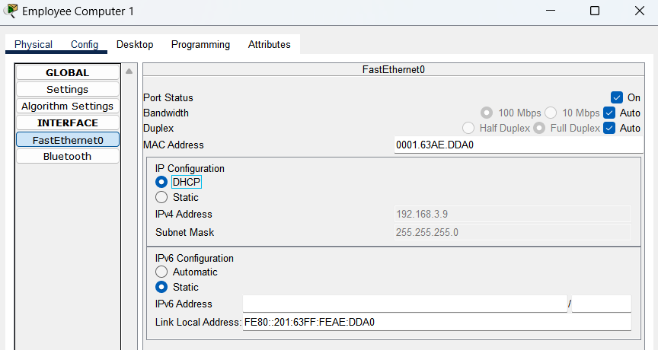

**Server Room**

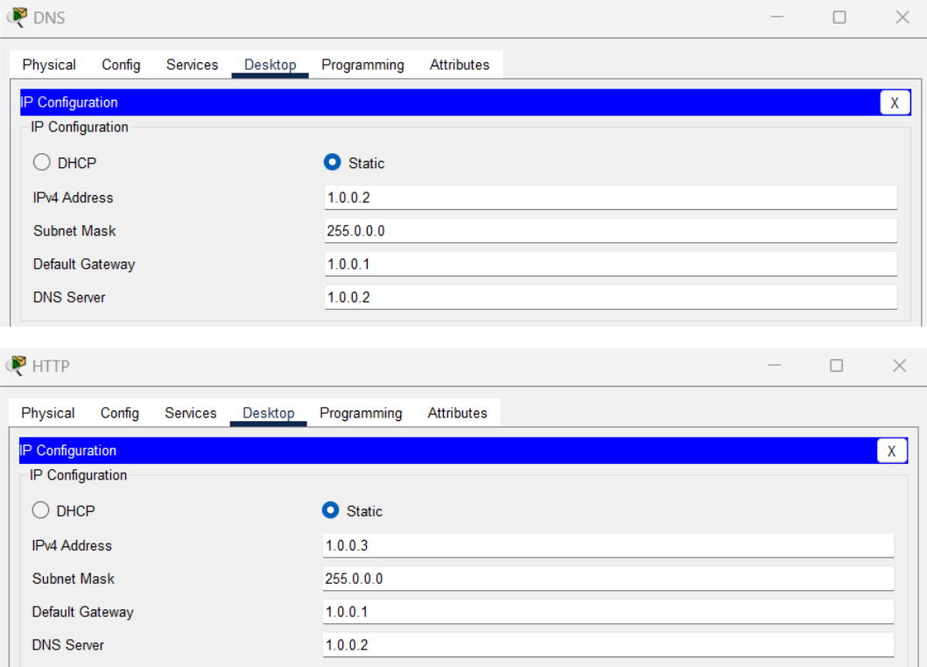

8

202044501 Computer Networks

**Main Router Config**

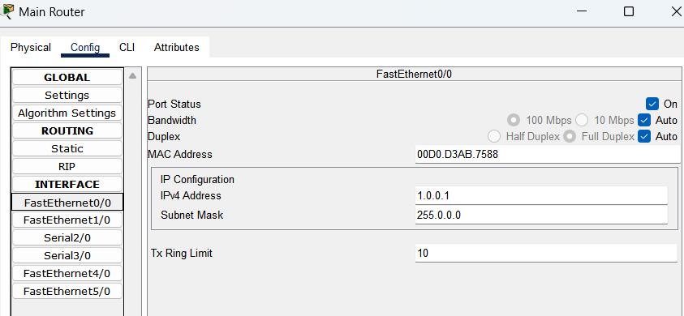

9

202044501 Computer Networks

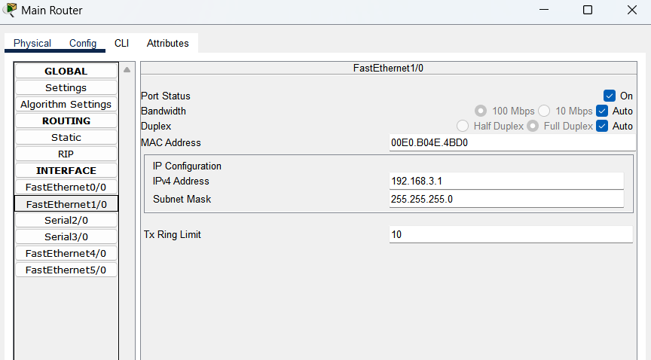

10

202044501 Computer Networks

**Extended Router Config**

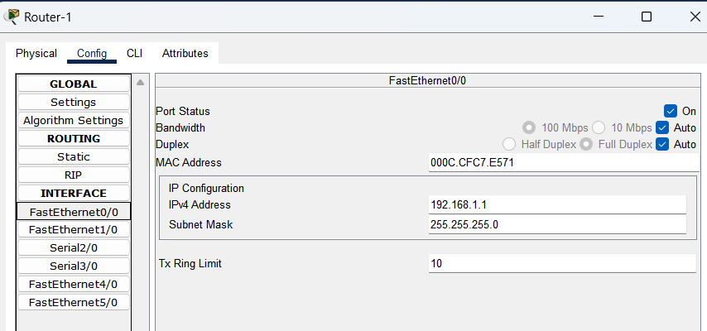

11

202044501 Computer Networks

**Step 5:** Go to DNS Server and select services and then DNS and then do the following

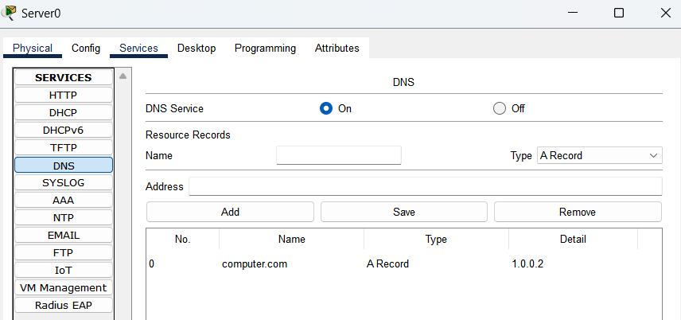

12

202044501 Computer Networks

**Step 6: Testing the Network**

* Test the setup pinging from a **PC in one department** (e.g., PC in Computer Department) to a **PC in another department** (e.g., PC in IT Department).
* Ensure that the packet travels through the routers successfully, verifying the RIP configuration.

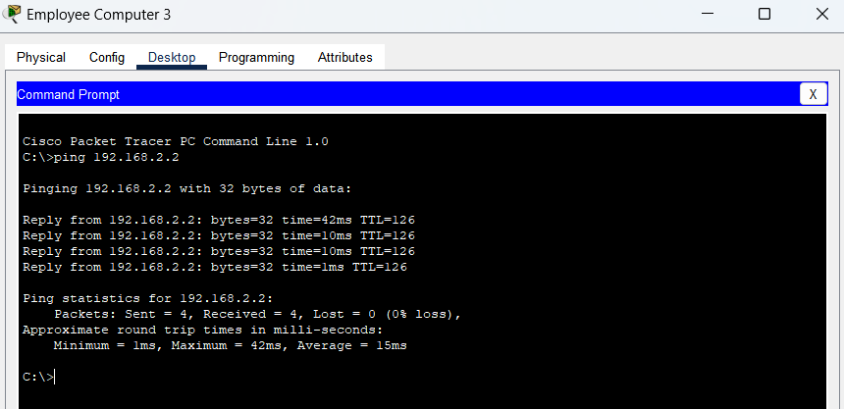

**Step 7: Testing Sever Web**

Now open Browser from any PC and enter the URL we added in DNS Server to see if the website is working

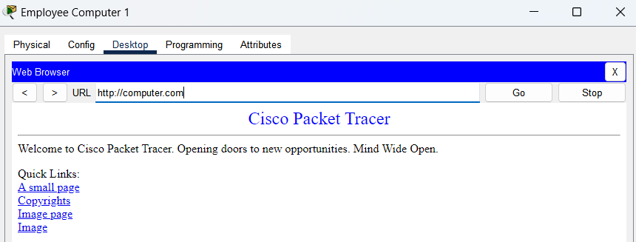

13

202044501 Computer Networks

**4. Conclusion**

This SOHO network design provides a robust, scalable, and easy-to-manage solution for small office environments. The use of separate subnets for each department ensures that network traffic is isolated, improving performance and security. Centralized services like DHCP and DNS make it easy to manage devices, while the main router handles inter-department communication.

The network’s simplicity, combined with basic services like file sharing and printing, offers an efficient setup that meets the needs of small offices or home offices. The flexibility of the network allows for future expansion as more devices or departments are added, without requiring major changes to the existing infrastructure.

